**附件1：**

运动场地示意图

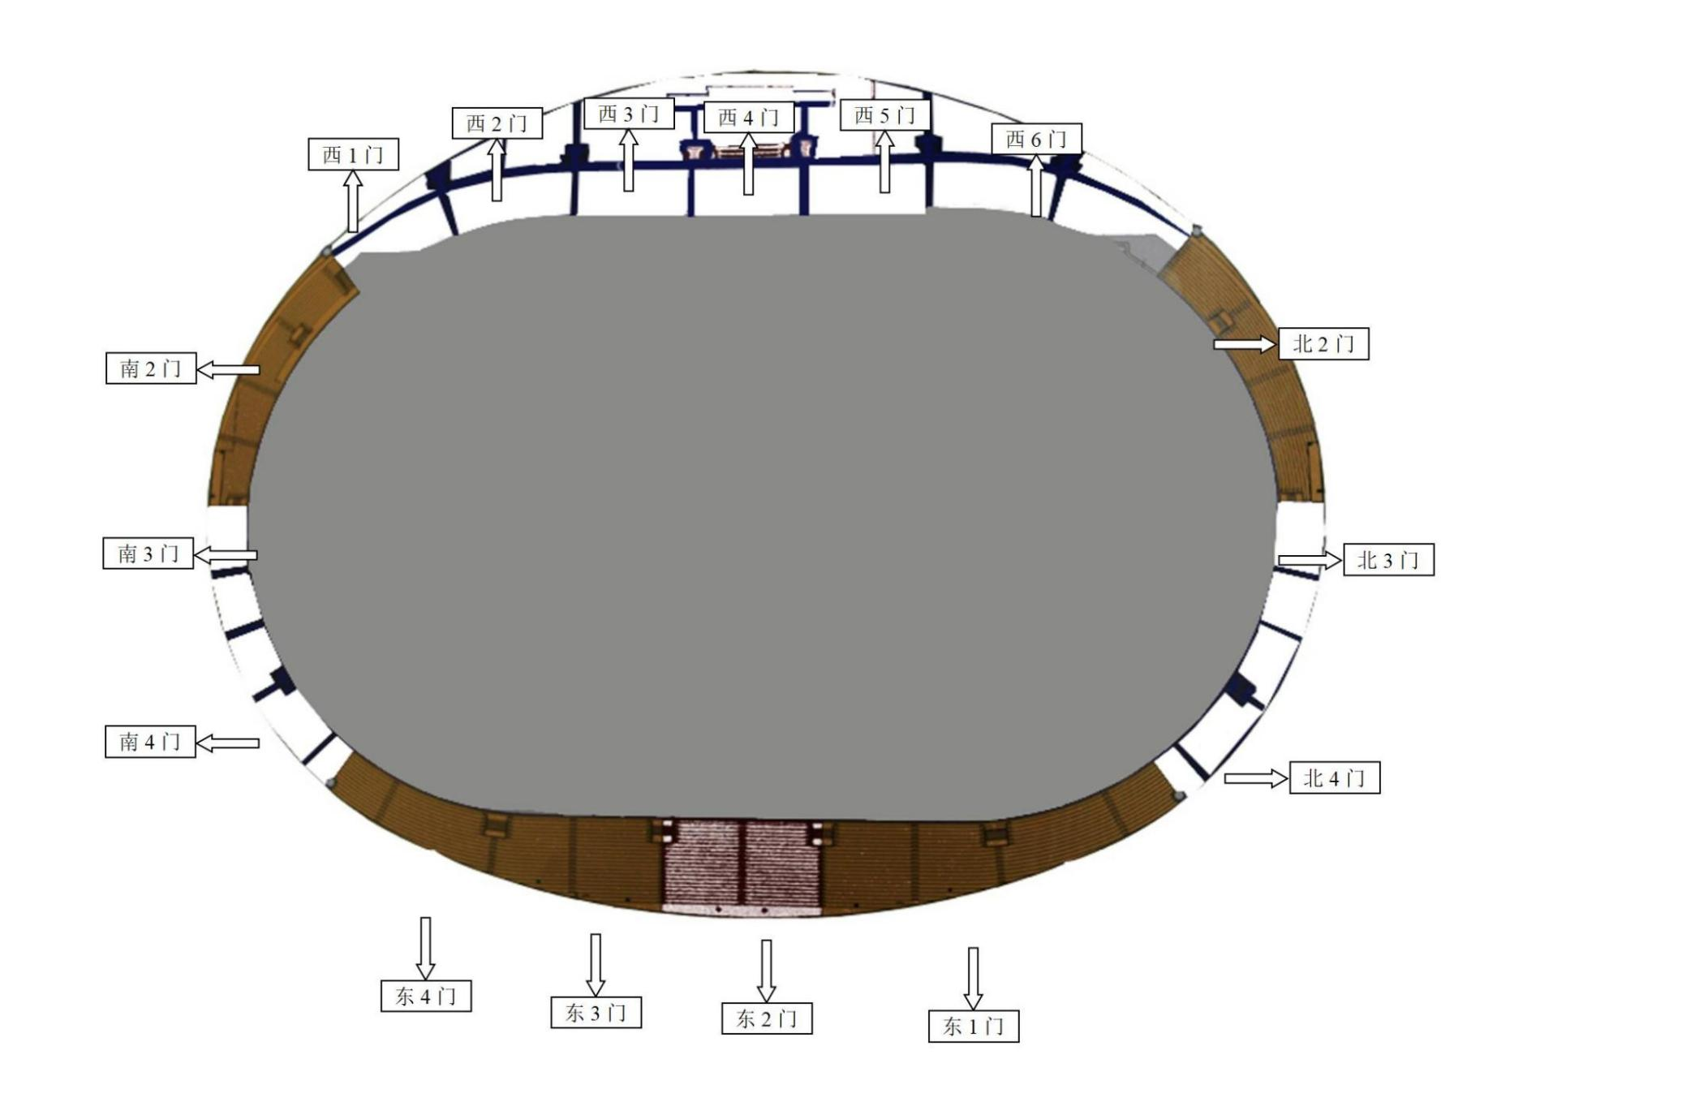

**起点处**

**附件2：**

江西师范大学2024年“悦跑”活动报名表

学 院：(学院盖章)

领 队： 联系方式:

|  |  |  |  |  |  |
| --- | --- | --- | --- | --- | --- |
| **序号** | **姓名** | **年级班级** | **学号** | **联系方式** | **备注** |
|  |  |  |  |  |  |
|  |  |  |  |  |  |
|  |  |  |  |  |  |
|  |  |  |  |  |  |
|  |  |  |  |  |  |
|  |  |  |  |  |  |
|  |  |  |  |  |  |
|  |  |  |  |  |  |